

**REPUBLIC OF CAMEROON**

Peace - Work - Fatherland

----------------

**Ministry of higher Education**

**------------------**

**THE UNIVERSITY INSTITUTE OF THE COAST**

-----------------

**UNIVERSITY OF BUEA**

----------------

**REPUBLIQUE DU CAMEROUN**

Paix - Travail - Patrie

**Ministère de l’enseignement supérieure**

---------------

**INSTITUT UNIVERSITAIRE DE LA COTE**

-----------------

**UNIVERISTE DE BUEA**



**DESIGN AND IMPLEMENTATION OF A**

**MICROFINANCE MANAGEMENT SYSTEM**

Internship from 1july to 31st August at Softechnology

Field study: **Computer Engineering**

Specialty: **SOFTWARE ENGINEERING**

Written and presented by: **DJIMENE FOMETIO GLORIA FAITH**

Under the direction of

Professional supervisor

**Mr. FECKOUNDO TCHINDA**

CEO of Soft Technologies

onnel

**Mr. Georges MOMO**

PDG de CSS Engineering

onnel

**Mr. Georges MOMO**

PDG de CSS Engineering

onnel

**Mr. Georges MOMO**

PDG de CSS Engineering

onnel

**Mr. Georges MOMO**

PDG de CSS Engineering

onnel

**Mr. Georges MOMO**

PDG de CSS Engineering

onnel

**Mr. Georges MOMO**

PDG de CSS Engineering

onnel

**Mr. Georges MOMO**

PDG de CSS Engineering

onnel

**Mr. Georges MOMO**

PDG de CSS Engineering

onnel

**Mr. Georges MOMO**

PDG de CSS Engineering

onnel

**Mr. Georges MOMO**

PDG de CSS Engineering

onnel

**Mr. Georges MOMO**

PDG de CSS Engineering

onnel

**Mr. Georges MOMO**

PDG de CSS Engineering

onnel

**Mr. Georges MOMO**

PDG de CSS Engineering

onnel

**Mr. Georges MOMO**

PDG de CSS Engineering

onnel

**Mr. Georges MOMO**

PDG de CSS Engineering

onnel

**Mr. Georges MOMO**

PDG de CSS Engineering

onnel

**Mr. Georges MOMO**

PDG de CSS Engineering

onnel

**Mr. Georges MOMO**

PDG de CSS Engineering

onnel

**Mr. Georges MOMO**

PDG de CSS Engineering

onnel

**Mr. Georges MOMO**

PDG de CSS Engineering

onnel

**Mr. Georges MOMO**

PDG de CSS Engineering

onnel

**Mr. Georges MOMO**

PDG de CSS Engineering

onnel

**Mr. Georges MOMO**

PDG de CSS Engineering

onnel

**Mr. Georges MOMO**

PDG de CSS Engineering

onnel

**Mr. Georges MOMO**

PDG de CSS Engineering

onnel

**Mr. Georges MOMO**

PDG de CSS Engineering

onnel

**Mr. Georges MOMO**

PDG de CSS Engineering

onnel

**Mr. Georges MOMO**

PDG de CSS Engineering

onnel

**Mr. Georges MOMO**

PDG de CSS Engineering

onnel

**Mr. Georges MOMO**

PDG de CSS Engineering

onnel

**Mr. Georges MOMO**

PDG de CSS Engineering

Academic supervisor

**Mr. FONKOU LESTER**

Administrative staff at IUC

Encadreur académique

**Dr NKONJOH NGOMADE**

**Armel**

Encadreur académique

**Dr NKONJOH NGOMADE**

**Armel**

Encadreur académique

**Dr NKONJOH NGOMADE**

**Armel**

Encadreur académique

**Dr NKONJOH NGOMADE**

**Armel**

Encadreur académique

**Dr NKONJOH NGOMADE**

**Armel**

Encadreur académique

**Dr NKONJOH NGOMADE**

**Armel**

Encad**DEDICACE**démique

**Dr NKONJOH NGOMADE**

**Armel**

Encadreur académique

**Dr NKONJOH NGOMADE**

**Armel**

Encadreur académique

**Dr NKONJOH NGOMADE**

**Armel**

Encadreur académique

**Dr NKONJOH NGOMADE**

**Armel**

Encadreur académique

**Dr NKONJO****DEDICACEE**

**Armel**

Encadreur académiqu**REMERCIEMENTSNGOMADE**

**Armel**

Encadreur académique

**Dr NKONJOH NGOMADE**

**Armel**

Encadreur académique

**Dr NKONJOH NGOMADE**

**Armel**

Encadreur académique

**Dr NKONJOH NGOMADE**

**Armel**

Encadreur académique

**Dr NKONJOH NGOMADE**

**Armel**

Encadreur académique

**Dr NKONJOH NGOMADE**

**Armel**

Encadreur académique

**Dr NKONJOH NGOMADE**

**Armel**

Encadreur académique

**Dr NKONJOH NGOMADE**

**Armel**

Encadreur académique

**Dr NKONJOH NGOMADE**

**Armel**

Encadreur académique

**Dr NKONJOH NGOMADE**

**Armel**

Encadreur académique

**Dr NKONJOH NGOMADE**

**Armel**

Encad**DEDICACE**démique

**Dr NKONJOH NGOMADE**

**Armel**

Encadreur académique

**Dr NKONJOH NGOMADE**

**Armel**

Encadreur académique

**Dr NKONJOH NGOMADE**

**Arme****REMERCIEMENTS** académique**SOMMAIREJOH NGOMADE**

**Armel**

Encadreur académique

**Dr NKONJOH NGOMADE**

**Armel**

Encadreur académiqu**REMERCIEMENTSNGOMADE**

**Armel**

Encadreur académique

**Dr NKONJOH NGOMADE**

**Armel**

Encadreur académique

**Dr NKONJOH NGOMADE**

**Armel**

Encadreur académique

**Dr NKONJOH NGOMADE**

**Armel**

Academic year 2024/2025

# CERTIFICATION

This is to certify that an internship with the theme: **“DESIGN AND IMPLEMENTATION OF A MICROFINANCE MANAGEMENT SYSTEM”:** case of CamCUL , is originally written and presented by **DJIMENE FOMETIO GLORIA FAITH** after a two month of internship carried out at **SOFTECH** to meet up with the partial the requirement and regulation governing the award of the Higher National Diploma (HND) of Institut Universitaire de la Cote in the field Software Engineering.

**PROFFESSIONAL SUPERVISOR**

**Mr FECKOUNDOU TCHINDA FABRICE**

SIGNATURE : ………………………

…

DATE : ………………………………

**ACADEMIC SUPERVISOR**

**MR FONKOU LESTER CONFIANCE**

SIGNATURE : …………………………

DATE : ………………………………

# DEDICATION

TO MY FAMILY

# ACKNOWLEDGEMENT

The accomplishment of this work required the assistance of some people. Failing to quote them individually here, they receive my most sincere thanks. I am practically grateful to :

* GOD ALMIGHTY for good health, strength, wisdom and the ability he invested in me for the completion of this work.
* Mr. GUIMEZAP Paul, Founder and President of IUC for the establishment of this structure for the purpose of training student.
* Mr. FONKOU LESTER, my academic supervisor, who have been a source of inspiration and motivation for me. Always providing me with task that helped me through my journey.
* Mr FECKOUNDO TCHINDA FABRICE, for granting me an internship in his company, and also for his guide and advises during my internship.
* ALL MY LECTURERS for my knowledge they installed in me.
* MY LOVELY AND SUPPORTIVE FAMILY for all their moral and financial support especially for the furthering my education.
* All my FRIENDS AND CLASSMATES who contributed in one way or the other for the realization of this project.
* To everyone I have failed to mention here, thank you.

# ABSTRACT

Banking is an integral part of human history and modern society. It is a system that enables individuals and businesses to manage their finances and engage in economic activities. The history of banking spans thousands of years, evolving from rudimentary systems in ancient civilizations to the global networks and digital innovations we see today.The technologycal advancements of the 19th century has made this to become easyer to handle. with the aim of laying and emphasis on the reliability ,security and a smooth management of the banking system which is made up of creating bank accounts,saving money withdrawing money seeking for loans and loan reemboursement for the client and creating clients accounts managing clients transactions as well as validation of loans depending on the clients credibility, we decided to built a web application that will handle these transaction in a user friendly manner and without major effort and taking into consideration security constraints.

# RESUME

La banque est une partie intégrante de l'histoire humaine et de la société moderne. C'est un système qui permet aux individus et aux entreprises de gérer leurs finances et de participer à des activités économiques. L'histoire de la banque s'étend sur des milliers d'années, évoluant depuis des systèmes rudimentaires dans les civilisations anciennes jusqu'aux réseaux mondiaux et aux innovations numériques que nous connaissons aujourd'hui. Les avancées technologiques du XIXe siècle ont rendu ce système plus facile à gérer. Avec pour objectif de mettre l'accent sur la fiabilité, la sécurité et une gestion fluide du système bancaire, qui comprend la création de comptes bancaires, l'épargne, les retraits d'argent, la demande de prêts, le remboursement des prêts pour les clients, la création de comptes clients, la gestion des transactions des clients ainsi que la validation des prêts en fonction de la crédibilité des clients, nous avons décidé de construire une application web qui gérera ces transactions de manière conviviale et sans effort majeur, tout en prenant en compte les contraintes de sécurité.

# PREFACE

With the aim of ensuring a suitable development and providing business with competent and competitive workface in various fields, the Cameroon government through the ministry of higher education has opened the private institution of education. This then created the HIGER **INSTITUTE OF TECHNOLOGY AND INDUSTRIAL DESIGN (ISTDI)** by decree No **02/0094/MINESUP/DDES/ESU**P of September 13 2002 and authorization of opening No01/02/MINESUP/DDES/ESUP of 18 September 2002, located in the coastal region, Wouri department, district of Douala 5th, in Logbessu district. The ISTDI then created the UNIVERSITY INSTITUTE OF THE COAST by decree No 5/05156/N/MINESDUP/DDES/ESUP/SAC/EBM.University Institute of the Coast (IUC) consist of five (5) different institution which are:

* **School of Engineering and Applied Science**

It consists of:

* **HND INDUSTRIAL PROGRAMS**
* Electrical power systems (EPS)
* Industrial Computing and Automation (ICA)
* Telecommunication (TEL)
* Software Engineering (SWE)
* Network Security (NWS)
* Chemical Manufacturing (CM)
* Mechanical Manufacturing (MEM)
* Building Science and Technology (BST)
* **HND COMMERCIALS PROGRAMS**
* Marketing (MKT)
* Management (MGT)
* Accountancy (ACC)
* Banking and Finance (BF)
* Logistic and Transport Management (LTM)
* **BTS PROGRAMS**
* GENIE CIVILE (GC)
* GEOMETRE TOPOGRAPH (GT)
* BATIMENTS
* TRAVEAUX PUBLIC (TPU)
* **BACHELORS OF ENGINEERING (B-Eng)**
* Computer Science Engineering
* Electromechanical Engineering
* Civil and Environmental Engineering
* **BACHELORS OF TECHNOLOGY (B-Tech)**
* Chemical Engineering
* Electrical and Electronics Engineering
* Civil Engineering
* Software Engineering
* Mechatronics Engineering
* Industrial Automation and Computing
* Welding and Fabrication Technology
* Thermal Engineering Technology
* **BACHELORS OF HEALTH SCIENCE (B-HES)**
* Physiotherapy
* Medical Laboratory
* Nursing Science
* **LIPRO**
* Genie Civil
* **MPRO**
* Genie Civil

**2. L’institut Supérieur des Technologies et du Design Industriel (ISTDI)**

It consist of :

* **BTS PROGRAMS**
* Génie Chimique des procèdes (GCP)
* Maintenance des systèmes informatique (MSI)
* Informatique Industriel (II)
* Electrotechnique (ET)
* Electronique (EN)
* Froid et climatisation (FC)
* Maintenance et après-vente automobile (MAVA)
* Bâtiment (BAT)
* Travaux publics (TP)
* Géomètre topographe (GT)
* Energie Renouvelable (ER)
* Génie Bois (GB)
* Chaudronnerie (CH)
* Fabrication Mécanique (FM)
* **DSEP PROGRAM :**
* Réseaux et Télécommunication (RT)
* **LICENCES PROFESSIONNELLES INDUSTRIELLES in partnership with the university of DSCHANG: VIII**
* Administration des systèmes Réseaux
* Génie Logiciel
* Automatique et Informatique Industriel
* Electrotechnique
* Electronique
* Management des systèmes Automobiles
* Maintenance et Expertise des Automobiles
* Maintenance des systèmes Industriels
* Génie Energétique et Industriel
* Production et commercialisation du bois
* Génie Mécanique et productique
* **MASTER PROFESSIONNEL COMMERCIAL in partnership with the University of DSCHANG**
* Génie Electrique et informatique Industriel
* Génie des Réseaux et Télécommunications
* Systèmes d’information et de Génie Logiciel
* Systèmes d’information Audit et Conseil

**3. L’institut de Commerce et d’Ingénierie d’affaire (ICIA)**

* BTS PROGRAMS
* Action Commercial
* Assurance
* Banque et Finance
* Communication d’Entreprise
* Commerce International
* Gestion Logistique et Transport
* Informatique de Gestion
* **LICENCES PROFESSIONNELLES COMMERCIALES ET GESTION in partnership with the University of DSCHANG:**
* Assurance
* Banque
* Banque – Assurance
* Comptabilité Control et Audit
* Finance – Comptabilité
* Gestion des Ressources Humaines
* Logistique et Transport
* Marketing
* Management des Opération du Commerce International IX
* **MASTER PROFESSIONNEL COMMERCIAL in partnership with the University of DSCHANG:**
* Finance – Comptabilité
* Audit Comptable et Financier
* Banque
* Fiscalité
* Management des Organisation
* Marketing – Communication
* Gestion des Ressources Humaines
* Logistique et Stratégique
* **MASTER ISUGA – France in partnership with EMBA France**
* EXECUTIVE MBA in partnership with ESSEC Douala

**4. L’institut d’Ingénierie Informatique d’Afrique Centrale (3IAC)**

* **Cycle des TIC in partnership with CCNB-DIEPPE of CANADA**
* Réseaux et sécurité
* Programmes et Analyse
* **MASTER EUROPEAN in partnership with 3IL France**
* Genie Logiciel
* Administration des Systèmes Réseaux
* **MASTER PROFESSIONENEL in partnership with ENSP Yaoundé**
* Génie Civil
* Génie Energétique et Environnement
* Génie Industriel et Maintenance
* **CYCLE INGENIEUR Information (3IL-France)**
* Pôle de Recherche Innovation et Entreprenariat

**5. LES PROGRAMMES INTERNATIONAUX DES SCIENCE ET TECHNOLOGIES DE L’INNOVATION (PISTI)**

* **Cycle des Classes Préparatoire au Grandes Ecoles d’Ingenieurs(CP) in partnership with the University of MAINE France**
* Classes préparatoires
* Licence Sciences et technique
* **CYCLE INGENIEUR de Génie Industriel (Polytechnique- NANCY France)**
* **INGENIEUR BIOMEDICAL in partnership with the University of Tor Vergata (ROME II)**
* **ARCHITECTURE ET DESIGN INDUSTRIEL in partnership with the University of CAMERINO (ROME I)**

# GENERAL INTRODUCTION

The technological advancements of the 19th century has brought light and joy to all the sectors of our day to day life and computer has become the main tool used in achieving and facilitating most tasks.it is the reason why we decided to develop a web application that will manage money transactions in a bank after creation of accounts.money, beeing the nerf of war should be delicately manage giving its sensitivity .

To achieve our goal, we will present on one hand the internship environment where we will present in chapter one the enterprise where we carried out our internship followed by the activities carried out during this period in chapter 2 and on the other hand the design of our sytem where we will study design and implement our system in chapter 3 and the results remarks and suggestions in chapter 4

# TABLES OF FIGURES

Figure 1 : organigram of soft technologies 28

Figure 2 : Agile methodology 36

Figure 3 use case diagram 42

Figure 4 : Activity Diagram for loan approval 43

Figure 5 : Class Diagram 43

Figure 6 : Admin dashboard 49

Figure 7 : Login page 50

Figure 8 : Client's transaction history 50

Figure 9 : Loan application requests 51

Figure 10 : Loan application form 51

**LIST OF TABLES**

Figure 1: organigram of soft technologies 28

Table 1: Activities carried out in softech 30

Figure 2: Agile methodology 36

Table 2: System Modules 38

Table 3: Non-functional requirements 39

Table 4: clients usecases 40

Table 5: Loan officer usecases 41

Table 6: Administrator usecases 41

Figure 3 use case diagram 42

Figure 4: Activity Diagram for loan approval 43

Figure 5: Class Diagram 43

Table 7: system user story 44

Figure 6: Admin dashboard 49

Figure 7: Login page 50

Figure 8: Client's transaction history 50

Figure 9: Loan application requests 51

Figure 10: Loan application form 51

# TABLE OF CONTENT

1.1. Mission 22

1.2. Presentation of the center  22

1.3. Center vision 23

1.4. Values 23

1.5. Pillars 23

1.6. Resources 23

1.8. Material resources 24

1.9. Financial resources 24

1.10. Organization 24

1.11. Structural analyses 25

1.12. Functional analyses 25

1.13. Chairman and CEO 25

1.14. Secretary/Accountant 25

1.15. Digital Communication Officer 26

1.16. Web Developper 26

1.17. The trainers 26

1.18. Operators 27

2.1 INTRODUCTION 28

2.2. PROJECTS I WORKED ON DURING INTERNSHIP 30

Introduction 33

3.1. Purpose 34

3.3. Examples of Semi-Manual Systems in Cameroon 34

3.3.2.1 Features of Small Rural MFIs 35

3.3.2.2. CHALLENGES FACED BY SMALL RURAL MFIs 35

3.4. Drawbacks of existing system 36

4.1.1 Importance of using agile methodology 37

4.2 Functional Requirements 38

4.2. Non-Functional Requirements 39

4.3. Stakeholders Analysis 40

5. System Architecture of a Microfinance Management System 45

Introduction 45

5.2. Software Requirements 47

I. Frontend 47

✓ HTML/CSS/JavaScript: Core technologies for building the user interface. 47

✓ Bootstrap: For responsive design and pre-built UI components. 47

5.3. Hardware Requirements 47

5.4. Tools and Technologies 48

4.1. Results 49

4.2 Remarks 51

4.3 Suggestions 52

4.3.1 Security Measures 52

4.3.2 Reliability 53

PERSPECTIVES 54

REFERENCES 54

Citations 55

## TABLE OF ABBREVIATIONS

* MFIs…………………. Microfinance Institutions
* HTML………………….. HyperText Markup Language
* PHP………………………. HyperText Preprocessor
* CamCCUL………………….. Cameroon Cooperative Credit Union League
* CSS ……………….Cascading Style Sheet
* API--------------------- Application Programming interface
* CI/CD --------------------Continuos Intergration/ Continuos Development
* JSON-------------------------Javascript Object Notation
* AWS--------------------------- Amazon Web Service
* CPU---------------------------- Central Processing Unit
* UI-------------------------- User Interface
* GB--------------- Giga Byte
* RAM---------------------- Random Access Memory
* MFA------------------------ Multi factor Authentication

# PART1: INTERNSHIP ENVIRONMENT

## Chapter 1: GENERAL PRESENTATION OF THE SOFT TECHNOLOGY

Soft Technology is a professional training organization that offers such as Initiation to numerical economics and crypto currency, Analysis and implementation of Blockchain projects, Active trading, Digital and community manager marketing, Blogging, Web redaction, Web development, Graphic design and branding, How to generate money online, Creation and management of an association/NGO, Network Installations and more.

### Mission

As part of projects, Soft Technologies trains people and find markets after training. After training, Soft Technologies takes the charge and supports these people interested to find markets on which they can work.

### Presentation of the center

Get an authentic certificate both by Soft Technologies and by expert partners who are supporting in order to offer excellent qualities of the courses. The educational approach of Soft Technologies relies on:

* **A career approach:** Soft Technologies accompanies in the development of your skills in order to ensure you find a job or improve you in a professional environment.
* **An entrepreneurial approach:** Soft Technologies has through available course modules on platforms, skills allow you to become an argue and warned entrepreneur.
* **A digital approach:** Soft Technologies is available to the learners, digital tools to facilitate their learning.

### Center vision

Soft Technologies has a better preparation of young people for employability, entrepreneurship and availability for all of a professional retraining.

### Values

Soft Technologies has a better preparation of young people for employability, entrepreneurship and availability for all of a professional retraining.

* Promote employability
* Promote entrepreneurship
* Improve professionalism

### Pillars

Soft Technologies has three pillars which relies on,

* Entrepreneurial spirit
* Creativity
* Professional competence
* Teach people how to block their time

### Resources

Every resource is defined with a set of attributes. The attributes are the properties of the resource. The resource of Soft Technologies includes;

* 1. **Human resources**

Soft Technologies by qualified personnel who devote their time and energy to the smooth functioning of the company. This includes:

* THE CEO
* SECRETARY/ACCOUNTANT
* WEB DEVELOPPER
* PERSON IN CHARGE OF THE DIGITAL COMMUNICATION
* PROFESSIONAL TRAINERS

### Material resources

Soft Technologies has two large offices, one located at Bonaberi and the second office located at Deido. The various material resources include;

* Air-conditioned offices of which (one reception room, two meeting rooms, computer equipments).
* One reception room made for the Secretary/Accountant.
* Two meeting rooms, one meeting room for the CEO and the last meeting room to receive people for training.

### Financial resources

Soft Technologies owns its funds from the training fees/tuition and the financing of the banks and personal savings.

### Organization

Soft Technologies as many other institutions have an organizational chart. This is in order to ease the achievement of their goals through the division of labour. By this, employees are shared to various departments having a supervisor.

### Structural analyses

Soft Technologies exercises its services in a dependent way with the supervisor of the state which is represented by the Minister of Small and Medium Enterprises.

### Functional analyses

Within it, Soft Technologies is committed to the voice of decentralized tasks in order to be close to young entrepreneurs and workers and provide them with effective services.

### Chairman and CEO

He is responsible for the supervision, management and coordination of overall operations. Which include, delegating and directing agendas, driving profitability,

managing company organizational structure, strategy and communicating with the board.

### Secretary/Accountant

The principal responsibility of the position is to maintain the unity and organizational effectiveness of the company’s movement as a whole while driving forward a program of renewal, and to advance its social and economic program.

The secretary accountant must have experience at a senior leadership level preferably within the company. Also, performs financial functions related to the collection, accuracy, recording, analysis and presentation of a business, organization or company’s financial operations…

Generally, the secretary accountant can also deal with the third parties, such as vendors, customers and financial institution such as Expression Union…. Staff accountant responsibility is to meet with clients to discuss their financial matters, such as real property, equipment and tax liability.

### Digital Communication Officer

It’s responsibility is to oversee the development and publishing of all digital communications content. He also assists the online campaigns, promoting the company’s products and goals to the public, either as part of a specific campaign or on a holistic level.

In general, a digital communication manager has the duty to manage a company’s website or blog, associating with content creation (e.g photography, graphic design, charts, polls, scripts…) analyzing relevant data and metrics, identifying new technologies and trends. Most digital communication managers work weekdays in an office setting.

### Web Developper

It has as function to ensure websites to look good and function properly. Web developers collaborate with website and graphic designers.

In general, the role of a web developer it to design, create and maintain websites, providing in the process a cohesive and user-friendly online portal for the use of clients, customers, work colleagues and other interested parties.

### The trainers

A trainer trains learner face-to-face or at a distance. He/she presents pedagogical content, offers activities and gives feedback to its learners.

The trainer must be enthusiastic and fool proof dynamism at every test. He is the first motivator of his learners and believe in his training. No matter the subject of the training, nor the general conditions, he must always be positive (through is smile) it’s very important.

### Operators

Soft Technologies has a lot of services it renders to clients which could be explained below:

* **PUBLICITY**

In terms of publicity, Soft Technologies uses the different social media to advertise its different products. Also, to let them understand that they could feel at home bringing in their problems this will definitely be heard and answered and by making great opportunities for the young and dynamic entrepreneurs.

## ORGANIGRAM OF SOFT TECHNOLOGIES

Figure 1: organigram of soft technologies

## CHAPTER2: ACTIVITIES CARRIED OUT AT SOFT TECHNOLOGY DURING INTERNSHIP

### 2.1 INTRODUCTION

Soft Technology is a professional training organization that offers such as Initiation to numerical economics and crypto currency, Analysis and implementation of Blockchain projects, Active trading, Digital and community manager marketing, Blogging, Web redaction, Web development, Graphic design and branding, How to generate money online, Creation and management of an association/NGO, Network Installations and more.

**SECTION1: ACTIVITIES CARRIED OUT BY SOFT TECHNOLOGY**

### 

Soft technology is a proffessional training center that carries out software activities which include :

* Initiation to numerical economics
* crypto currency
* Analysis and implementation of Blockchain projects
* Active trading
* Digital and community manager marketing
* Blogging
* Web redaction
* Web development
* Graphic design and branding
* How to generate money online
* Creation and management of an association/NGO
* Network Installations and computer maintenance.

### SECTION 2: WEEKLY ACTIVITIES

|  |  |  |  |  |
| --- | --- | --- | --- | --- |
| **WEEK** | **PERFORMED ACTIVITIES** | **DIFFICULTIES ENCOUNTERED** | **SOLUTIONS PROPOSED** | **SKILL ACQUIRED** |
| WEEK ONE | Joined a comprehensive orientation session on company culture and values.  Built connections with fellow interns through interactive icebreaker activities. | Adjusting to the new work environment and meeting new people. | Engaged actively in discussions and networking opportunities to build rapport with fellow interns and mentors. | Socialization skills  Understanding company culture |
| WEEK TWO | Participated in hands-on hardware maintenance tasks, including diagnostics and repairs.  Collaborated with peers on troubleshooting sessions for various devices | Some maintenance tasks were challenging to complete alone. | Collaborated in teams, dividing tasks to capitalize on each member's strengths, enhancing overall learning. | ¬ Advanced hardware troubleshooting  Team collaboration  Troubleshooting Technics |
| WEEK THREE | Designed and implemented a Car Management System with user-friendly interfaces.  Engaged in coding sessions, focusing on real-time feedback and continuous improvement. | Encountered challenges with PHP integration and JavaScript syntax. | Partnered with a more experienced intern for coding support and utilized online resources for deeper learning and alternative approaches. | Web page design proficiency  Programming skills in PHP & JS& JS |
| WEEK FOUR | Conducted a thorough analysis of existing systems at SOFTECH.  Selected a project topic based on identified needs, contributing to strategic planning and development. | Understanding the existing systems and their functionalities | Conducted thorough research and collaborative discussions with mentors to clarify concepts and identify solutions. | Knowledge in backend programming (Plain PHP)  Analytical and research skills |
| WEEK FIVE | Completed the internship evaluation process with reflections on personal growth.  Presented project concepts and outcomes to supervisors for feedback. | Managing self-directed projects remotely. | Established a structured plan for tasks and maintained regular communication with supervisors to ensure alignment and support. | Self-management  Presentation and communication skills |
| Week six |  |  |  |  |
| Week seven |  |  |  |  |

Table 1: Activities carried out in softech

### 2.2. PROJECTS I WORKED ON DURING INTERNSHIP

* CAR MANAGEMENT SYSTEM using BOOTSTRAP,JAVASCRIPT and PHP

**SECTION 3: JUSTIFICATION OF NEW SYSTEM**

Microfinance institutions (MFIs) play a critical role in providing financial services to underserved populations, particularly in developing economies. However, many MFIs face significant challenges, such as reliance on manual processes, lack of real-time data access, and poor user experience. During my internship at Soft Technology, I was part of a team tasked with developing a web application to address these challenges. This project allowed me to apply the knowledge and skills I gained during my academic studies, particularly in software development, database management, and system design, to solve real-world problems."

Soft technology offers a variety of activities and one of these activities is Web development and the fourth week of internship,soft tech was awarded a contract of web app development for a microfinance and I was priviledged to be the appointed members to carried out this task.For that that to be done, we carried out some research on some microfinances like Camcull and MFIs( Microfinance institutions). we discovered some short commings and decided to emphasise on the following points:

* **Fully Automate Processes:** Reduce errors and save time by automating loan applications, repayments, and reporting.
* **Provide Real-Time Updates:** Enable stakeholders to access real-time information for better decision-making.
* **Offer a User-Friendly Interface:** Improve usability for customers, loan officers, and admins.
* **Ensure Scalability:** Handle large volumes of data and growing user bases.
* **Enhance Security:** Protect sensitive data with robust encryption and authentication mechanisms.

# PART2 : CONCEPTUAL FRAMEWORK

## Chapter 3: SYSTEM ANALYSIS AND DESIGN

### Introduction

A microfinance management system that automates the operations of a microfinance institutions,improving efficiency,accuracy and customer satisfaction.The system will handle customer management, loan processing, repayment tracking, and financial reporting.

## SECTION 1: REVIEW OF EXIXTING SYSTEMS

### 3.1. Purpose

This section analyzes the current systems used in microfinance management in Cameroon, focusing on semi-manual and outdated automated solutions. The findings will highlight their limitations and justify the need for a new, improved system that addresses these gaps and better meets stakeholder needs.

#### ****3.2.** Overview of Existing Systems**

Many microfinance institutions (MFIs) in Cameroon, including prominent networks like CamCCUL (Cameroon Cooperative Credit Union League), rely on semi-manual systems that combine basic software tools (like Excel or older database systems) with manual processes. These systems are inefficient, error-prone, and difficult to scale, especially in rural areas and smaller branches.

### 3.3. Examples of Semi-Manual Systems in Cameroon

##### **3.3.1 CamCCUL (Cameroon Cooperative Credit Union League)**

**CamCCUL** is one of the largest microfinance networks in Cameroon, with over 300 affiliated credit unions.It serves both urban and rural areas, including cities like Douala and Yaoundé, as well as remote regions.

**3.3.1.1 Features (Characteristics of CAMCCUL)**

* **Loan Applications:** Customers fill out paper forms, which are manually entered into a database or spreadsheet.
* **Repayment Tracking:** Repayments are recorded manually in ledgers or spreadsheets and updated periodically.
* **Reporting:** Reports are generated using basic tools like Excel, leading to delays and errors.

**3.3.1.2 CHALLENGES FACED BY CAMCCUL**

* **Manual Processes:** Time-consuming and prone to errors.
* **Limited Integration:** Difficulty integrating with modern tools like payment gateways or credit bureaus.
* **No Real-Time Updates:** Stakeholders cannot access real-time information.**Resource Constraints:** Smaller or rural branches may lack the resources to fully adopt digital tools.

**3.3.2.** Small Rural MFIs

**Overview:**

Many small MFIs in rural areas of Cameroon use semi-manual systems due to limited access to technology and reliable internet.

### 3.3.2.1 Features of Small Rural MFIs

* **Loan Applications**: Recorded in spreadsheets or paper forms.
* **Repayment Tracking**: Manual updates in ledgers or spreadsheets.
* **Reporting**: Basic tools like Excel are used for generating reports.

### **3.3.2.2. CHALLENGES FACED BY SMALL RURAL MFIs**

* **Prone to Errors**: Manual data entry leads to mistakes.
* **Time-Consuming**: Processing loan applications and generating reports takes a long time.
* **No Real-Time Updates**: Stakeholders cannot access real-time information.

### **3.4. Drawbacks of existing system**

* **Prone to Errors**: Manual data entry leads to mistakes in loan calculations and repayment tracking.
* **Time-Consuming**: Processing loan applications and generating reports takes a long time.
* **Lack of Integration**: Difficulty integrating with modern tools like payment gateways or credit bureaus.

**No Real-Time Updates**: Stakeholders cannot access real-time information.

* **Limited Scalability**: Managing large volumes of data becomes difficult as the institution grows.

### 4.1 SYSTEM METHODOLOGY

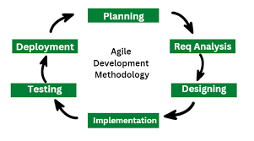

Figure 2: Agile methodology

Agile Methodology is a project management and software development approach that emphasizes flexibility, collaboration, customer feedback, and iterative progress. It focuses on delivering small, incremental releases of a product, allowing teams to adapt to changes quickly and efficiently. Agile is often contrasted with traditional, linear approaches like the Waterfall model.

### 4.1.1 Importance of using agile methodology

* **Adaptability to Change**: Agile allows teams to respond to changing requirements, even late in the development process. This is crucial in software development, where customer needs and market conditions can evolve rapidly.
* **Customer-Centric Approach**: Agile prioritizes customer satisfaction by involving them throughout the development process. Regular feedback ensures the final product aligns with their expectations.
* **Faster Delivery:** By breaking the project into smaller, manageable increments (sprints), Agile enables teams to deliver functional parts of the software quickly, providing value to customers sooner.
* **Improved Collaboration**: Agile promotes teamwork and communication among cross-functional teams, stakeholders, and customers, fostering a collaborative environment.
* **Continuous Improvement**: Regular retrospectives allow teams to reflect on their processes and make improvements, leading to higher efficiency and quality over time.
* **Risk Management**: Agile reduces risks by identifying and addressing issues early in the development cycle, rather than at the end.
* **Cultural Resistance**: Organizations accustomed to traditional methods may face resistance when transitioning to Agile, as it requires a shift in mindset and processes.

### 4.2 Functional Requirements

Functional requireents of a microfinance management system are those activities that the system can do. As seen on the table below. Functional requirements describe the specific features and functionalities of your system. These are derived from the needs of the stakeholders identified in your analysis.

|  |  |
| --- | --- |
| **Modules** | **Functional Requirements** |
| **Customer Management** | - Allow customers to register by providing personal details. |
|  | Enable customers to update their profile information. |
| **Loan Management** | - Allow customers to apply for loans online. |
|  | - Enable loan officers to approve/reject loan applications. |
| **Repayment Tracking** | - Record loan repayments and generate repayment schedules. |
|  | - Send automated reminders for overdue payments. |
| **Transaction Management** | - Record all financial transactions and generate receipts. |
| **Reporting** | - Generate loan performance reports and financial summaries. |
| **User Authentication** | - Provide secure login and role-based access control. |
| **Notifications** | Send email/SMS notifications for important events. |

Table 2: System Modules

### **4.2. Non-Functional Requirements**

The non-functional requirements are those requirements that describes how the system should perform rather than what they should do.

* **Performance:** The system should handle up to 1,000 concurrent users.
* **Security:** Data encryption and secure user authentication.
* **Usability:** User-friendly interface for both staff and customers(clients).
* **Scalability:** The system should be scalable to accommodate future growth.
* **Portability:** The system should be compatible with major browsers (Chrome, Firefox, Safari, Edge) and operating systems (Windows, macOS, Linux).

Below is the summarized non functional requirements of the system:

|  |  |
| --- | --- |
| **Category** | **Requirements** |
| **Performance** | The system should handle up to 1,000 concurrent users. |
| **Scalability** | The system should scale to support up to 10,000 users. |
| **Security** | All sensitive data must be encrypted using AES-256 encryption. |
| **Availability** | The system should have an uptime of 99.9%. |
| **Usability** | The system should have an intuitive user interface. |
| **Reliability** | The system should have an MTBF of at least 1,000 hours. |
| **Maintainability** | The system should support CI/CD for easy updates. |
| **Portability** | The system should be compatible with major browsers and operating systems. |
| **Backup** | The system should perform daily automated backups. |

Table 3: Non-functional requirements

### 4.3. Stakeholders Analysis

Stakeholders analysis involves: The identification of the system actors,their roles (usecases) and description.The Microfinance Management System involves multiple stakeholders, each with specific roles and needs. The table below outlines the key actors, their use cases, and descriptions of how they interact with the system. This analysis ensures that the system meets the needs of all stakeholders, from customers and loan officers to admins and regulators.

#### 4.3.1 Customers

|  |  |
| --- | --- |
| **Use case** | **Description** |
| Register | Customers create an account by providing personal details. |
| Apply for Lean | Customers fill out a loan application form and submit it for review. |
| View Loan Status | Customers check the status of their loan application (e.g.,pending, approved). |
| Make Repayment | Customers make loan repayments through the system. |
| View Repayment Schedule | Customers view their loan repayment schedule and due dates. |
| Update Profile | Customers update their personal information (e.g., phone number, address). |
| View Transaction History | Customers view their transaction history (e.g., loans repayments). |

Table 4: clients usecases

#### 4.3.2 Loan Officers

|  |  |
| --- | --- |
| **Use case** | **Description** |
| Review Loan Application | Loan officers review loan applications submitted by customers. |
| Approve/Reject Loan | Loan officers approve or reject loan applications based on eligibility. |
| View Customer Details | Loan officers view customer profiles and loan history. |
| Generate Loan Agreement | Loan officers generate a loan agreement for approved loans. |
| Disburse Loan | Loan officers disburse the loan amount to the customer’s account. |

Table 5: Loan officer usecases

**4.3.3** Manager( System administrator)

|  |  |
| --- | --- |
| **Use Case** | **Description** |
| Manage Customers accounts. | Admins add, update, or delete customer accounts. |
| Manage Loan Officers | Admins add, update, or delete loan officer accounts. |
| Generate Reports | Admins generate reports on loans, repayments, and financial performance. |
| Monitor System | Admins monitor system performance and resolve issues. |
| Configure System Settings | Admins configure system settings (e.g., interest rates, notification templates). |

Table 6: Administrator usecases

4.3.4 Use case diagram

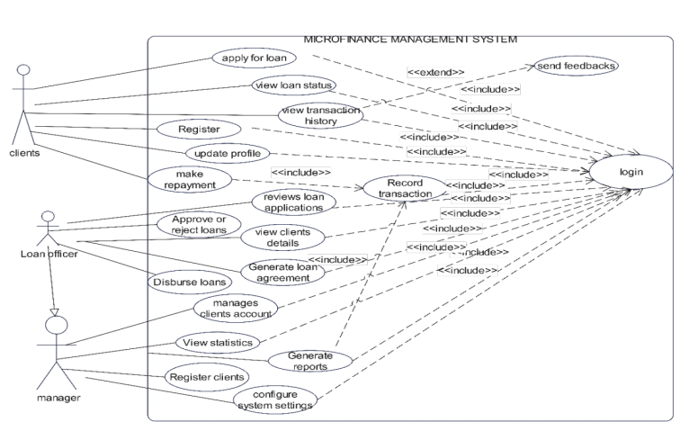

Figure 3 use case diagram

The diagram above shows how different users interacts with the system

4.3.5 Activity Diagram

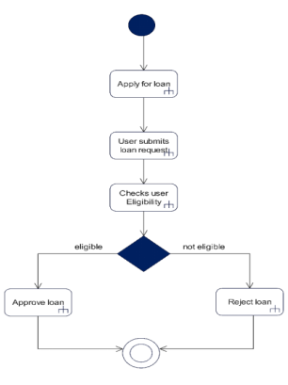

Figure 4: Activity Diagram for loan approval

4.3.6 Class Diagram

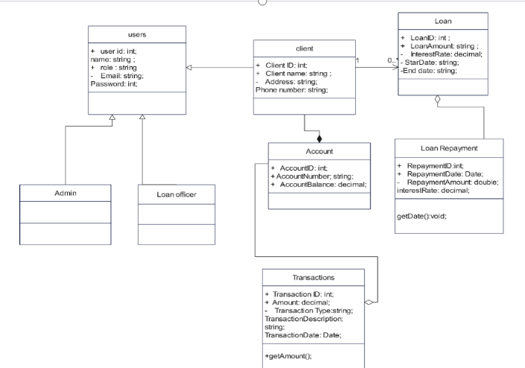

Figure 5: Class Diagram

**4.3.4** User Stories of the microfinance management system

|  |  |
| --- | --- |
| **User Type** | **User Story** |
| **Customer** | "As a customer, I want to register for an account so that I can apply for loans and manage my finances." |
| **Customer** | "As a customer, I want to log in to my account so that I can access my loan details and repayment schedules." |
| **Customer** | "As a customer, I want to apply for a loan online so that I don’t have to visit the office." |
| **Customer** | "As a customer, I want to check the status of my loan application so that I know if it’s approved or rejected." |
| **Customer** | "As a customer, I want to make loan repayments online so that I can avoid late fees." |
| **Customer** | "As a customer, I want to update my personal information so that my details are always accurate." |
| **Customer** | "As a customer, I want to view my transaction history so that I can track my loans and repayments." |
| **Loan Officer** | "As a loan officer, I want to review loan applications quickly so that I can make faster decisions." |
| **Loan Officer** | "As a loan officer, I want to approve or reject loan applications so that customers can receive their loans promptly." |
| **Customer** | "As a customer, I want to view my repayment schedule so that I can plan my finances." |
| **Loan Officer** | "As a loan officer, I want to view customer details so that I can verify their eligibility for a loan." |
| **Loan Officer** | "As a loan officer, I want to generate loan agreements automatically so that I can save time." |
| **Loan Officer** | "As a loan officer, I want to disburse loans to customers so that they can access the funds quickly." |
| **Loan Officer** | "As a loan officer, I want to track overdue repayments so that I can send reminders to customers." |
| **Admin** | "As an admin, I want to add, update, or delete customer accounts so that the system’s data is accurate." |
| **Admin** | "As an admin, I want to manage loan officer accounts so that I can control access to the system." |
| **Admin** | "As an admin, I want to generate reports on loans and repayments so that I can monitor the system’s performance." |
| **Admin** | "As an admin, I want to monitor the system’s performance so that I can resolve issues". |

Table 7: system user story

### System Architecture of a Microfinance Management System

## **Introduction**

The Microfinance Management System (MMS) is a software solution designed to streamline the operations of microfinance institutions (MFIs). This document outlines the system architecture, including its components, layers, and deployment strategy, ensuring scalability, security, and efficiency.

#### 5.1 System Overview

The Microfinance management system follows a **three-tier architecture**, consisting of:

* **Presentation Layer** (User Interface)
* **Application Layer** (Business Logic)
* **Database Layer** (Data Storage)

This modular approach ensures maintainability, security, and ease of integration with third-party services.

#### 5.1.2. Architectural Design

##### 5.1.2.1 Presentation Layer (Front-End)

* Provides user-friendly interfaces for customers, loan officers, and administrators.
* Accessible via web portal, mobile app, or desktop interface.
* Technologies: HTML, CSS, JavaScript (Bootstrap),dynamic UI).
* Implements Role-Based Access Control (RBAC) to restrict access based on user roles.

##### 5.1.2.2. Application Layer (Back-End & Business Logic)

* Core processing unit handling loan approvals, disbursements, repayments, and customer management.
* Implements **secure authentication**  for user sessions.
* Technologies: PHP **, fetch** API’s**.**

##### 5.1.2.3. Database Layer

* Stores structured financial data, customer records, and transaction logs.
* Supports ACID**-compliant relational databases** for data integrity.
* Technologies: MySQL **database.**

#### 5.1.3. Deployment Architecture

The system supports multiple deployment models:

* **On-Premise Deployment**: Hosted on institutional servers for full control.
* **Cloud-Based Deployment**: Scalable hosting on AWS, Azure, or Google Cloud.
* **Hybrid Deployment**: Combination of on-premise and cloud storage for enhanced security.

#### 5.1.4 Security Considerations

* Data Encryption: AES-256 encryption for sensitive transactions.
* **Role-Based Access Control (RBAC)**: Restricts user permissions.
* **Two-Factor Authentication (2FA)**: Adds an extra layer of login security.
* **Regular Backups & Disaster Recovery**: Automated database backups to prevent data loss.
* **Logging & Monitoring**: Tracks user activities for compliance and auditing.

### 5.2. Software Requirements

### ****Frontend****

### ****HTML/CSS/JavaScript****: Core technologies for building the user interface.

### ****Bootstrap****: For responsive design and pre-built UI components.

* **React.js (Optional)**:If you want a more dynamic and interactive frontend, you can use React.js.

#### ****Backend****

* **PHP** : plain PHP for running the backend.
* **Bcrypt**: Library for hashing passwords.
* **MySQL**: Relational database for storing user data.
* **JSON Web Tokens (JWT)**: For secure user authentication and session management.

#### ****Database****

* **MySQL**: Relational database management system (RDBMS) for storing and managing data.

1. **Development Tools**

* **VS Code**:Code editor for writing and debugging your application.
* **Git**:Version control system for tracking code changes.

### 5.3. Hardware Requirements

#### ****5.3.1 Development Environment****

* **Computer**:A modern laptop or desktop with at least 8GB RAM and a multi-core processor.
* **Operating System**:Windows 10 proffessional.

#### ****5.3.2 Production Environment****

* **Server** :A cloud-based server (e.g., AWS, Google Cloud, Azure) or a physical server.
* **Minimum requirements:**
* 2 CPU cores
* 4GB RAM
* 500GB SSD storage

### 5.4. Tools and Technologies

#### ****Frontend Tools****

**Bootstrap**: For responsive and pre-styled UI components.

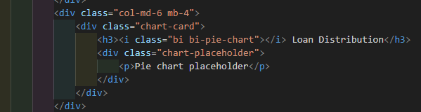

**Javascript:** To add certain functionalities and add dynamic pages.

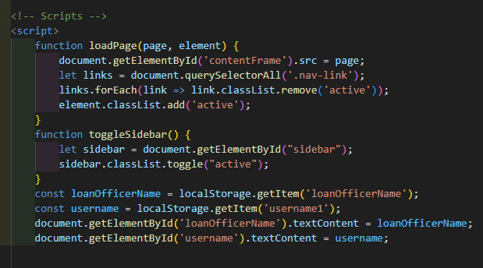

#### ****Backend Tools****

**PHP**:JavaScript runtime for building the backend.

**Password_Hash**:For hashing passwords.

**Fetch API** : To fetch users data.

**Stripe API** : For payment Gateway (Through credit Card)

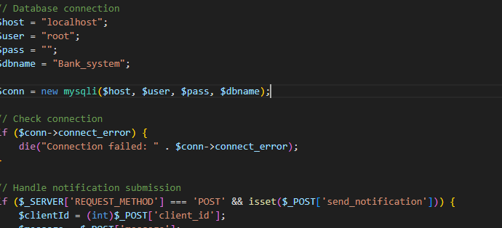

## Chapter 4: RESULTS,REMARKS AND SUGGESTIONS

### 4.1. Results

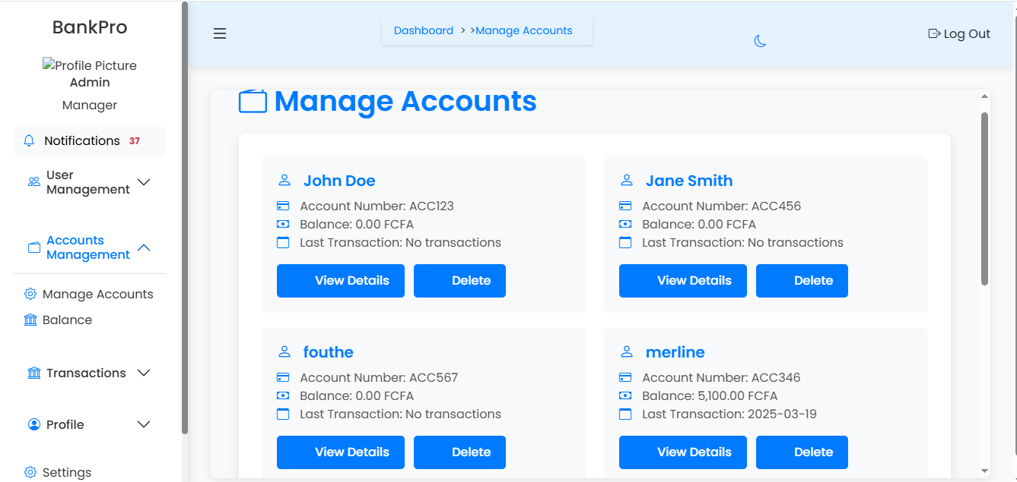

Figure 6: Admin dashboard

**Admin Dashboard**

From the GUI above , we can see that the admin can perform the following functionalities:

* He can manage clients account( he can view clients detail and delete them if necessary.
* He can view the microfinance balance
* He can view client transaction history and recent clients registration)
* He can create customer account by oversighting the clients self registration( to enhance security).
* He can view transaction reports.
* He can change the system settings and view notifications sent by the system.

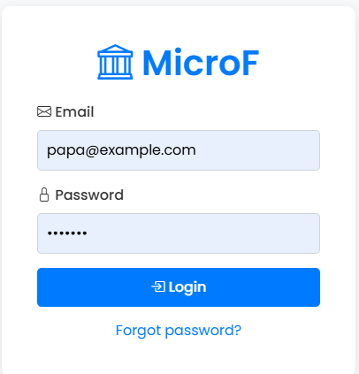

Figure 7: Login page

**Login Page**

* The login page permits actors of the system( Microfinance management system to view their respective dashboards).
* The actors provides the following info : Email and password for submission.

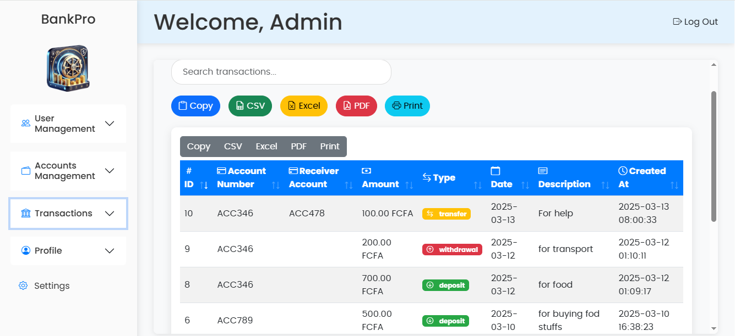

Figure 8: Client's transaction history

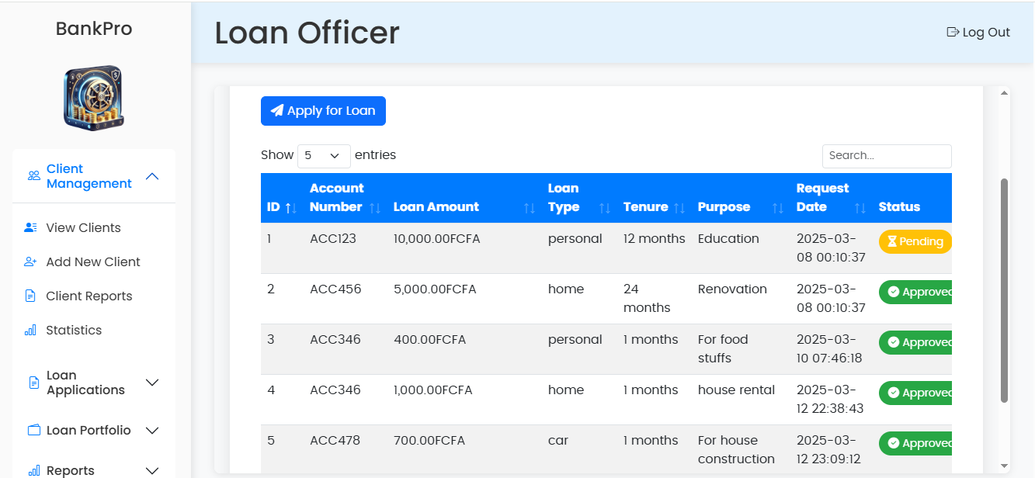

Figure 9: Loan application requests

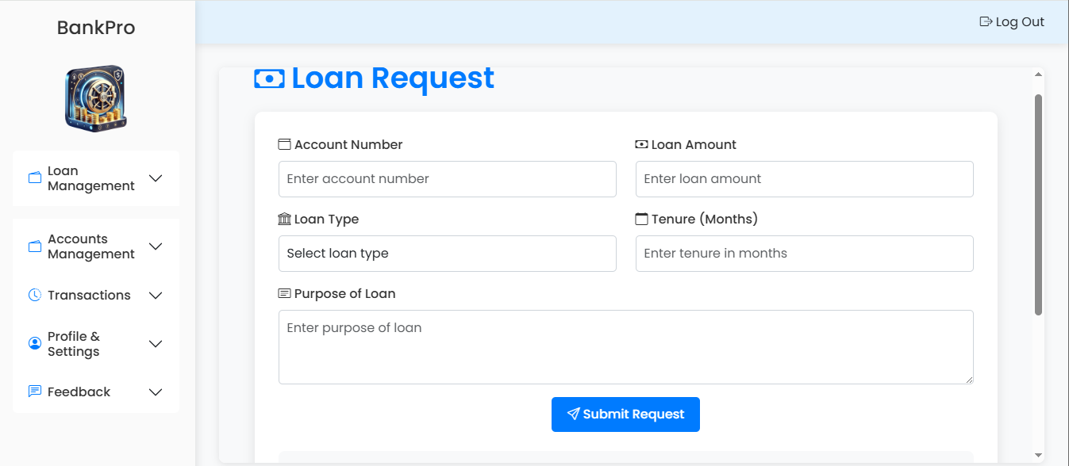

Figure 10: Loan application form

## 4.2 Remarks

## 4.3 Suggestions

Below are the improvements we can make to enhance the microfinance management system.

### 4.3.1 Security Measures

**4.3.1.1. Data Encryption**

1. Use strong encryption protocols for data at rest and in transit to protect sensitive client information.

**4.3.1.2 Multi-Factor Authentication (MFA)**

Implement MFA for both users and administrators to add an extra layer of security against unauthorized access.

**4.3.1.3 Regular Security Audits**

Conduct periodic security assessments and vulnerability scans to identify and mitigate potential risks.

**4.3.1.4 Access Control Policies**

Establish strict access controls based on user roles to ensure that only authorized personnel can access sensitive data.

**4.3.1.5 Incident Response Plan**

Develop a comprehensive incident response plan to quickly address any security breaches or data leaks.

**4.3.1.6 Secure Software Development**

Follow secure coding practices during development to minimize vulnerabilities in the software.

**4.3.1.7 User Education**

Provide training for users and staff on best practices for security, including recognizing phishing attacks and safe data handling.

### 4.3.2 Reliability

**4.3.2.1 System Redundancy**

Implement redundant systems and backup solutions to ensure data availability and minimize downtime in case of failures.

**4.3.2.2 Regular Maintenance and Updates**

Schedule regular maintenance and software updates to fix bugs, improve performance, and enhance security.

**4.3.2.3 Performance Monitoring**

Use monitoring tools to track system performance and detect anomalies that may indicate underlying issues.

**4.3.2.4 Scalability**

Design the system to handle increased loads without degradation in performance, ensuring reliability during peak usage times.

**4.3.2.5 Disaster Recovery Plan**

Develop and regularly test a disaster recovery plan to ensure quick restoration of services in the event of a catastrophic failure.

**4.3.2.6 User Support and Documentation**

Provide comprehensive documentation and support resources to assist users in troubleshooting and resolving issues promptly.

By focusing on these security measures and reliability enhancements, the microfinance management system can better protect client data and ensure consistent, dependable service delivery.

**CONCLUSION**

In this project, the development of the Enterprise Information System was to facilitate the management of the enterprise. The system is a low-cost, simple, user-friendly system and calculations are done within few seconds. The system contains multi-features for the effective management of the company’s I learned a lot from developing this project, research done from the internet increased my skills and abilities as a Software developer especially in developing databases and program designing.

Finally, my internship at **SOFTECH** was very constructive and enriching because one thing led me to learn many other things. I honed my solution-construction aptitudes which is a musthave skill in the job environments today. I learnt many things in software engineering especially on web development that helped me to come out with the **MICROFINANCE MANAGEMENT** **SYSTEM** In conclusion the internship was very good.

### PERSPECTIVES

As technology keeps on developing and new requirements come up every day, our work cannot be said to be complete. The work we have done meets the requirements and objectives set at the beginning of the internship. However, it can still evolve and be improved.

### REFERENCES

* Martin Robert C. - UML Tutorial_ Part 1 - Class Diagrams Using UML. Part One. Structural Modelling Diagrams Using UML. Part Two. Behavioural Modelling Diagrams UML 2
* https://www.slideshare.net/slideshow/bank-management-system/1358395.

### Citations

· **Zins, A.H. (2009)**. "Microfinance: A new approach to financing development." International Journal of Social Economics, 36(6), 676-688.

* · Discusses the role of microfinance in development and the importance of technology in enhancing its effectiveness.

· **Morduch, J. (1999)**. "The Microfinance Promise." Journal of Economic Literature, 37(4), 1569-1614.

* · Analyzes the impact of microfinance on poverty alleviation and the necessity for efficient management systems to support microfinance institutions.

· **Kumar, R., & Kumar, A. (2018)**. "Design and Development of Microfinance Management System." International Journal of Computer Applications, 182(2), 34-39.

* · A case study on the design and implementation of a microfinance management system, highlighting software engineering practices.

· **Banerjee, A. V., & Duflo, E. (2011)**. "Poor Economics: A Radical Rethinking of the Way to Fight Global Poverty." PublicAffairs.